PSP0201 – Mini IT Project

  Trimester 3

[2019/2020]

TECHNICAL REPORT

**ABSTRACT**

Nowadays the life of people is different. People feel uncomfortable and time consuming going to crowded markets. So, E-Shopping may be a solution because it saves a lot of your time. Online shopping may be a process whereby consumers directly buy goods, services etc. from a seller without an intermediary service over the web. Shoppers can visit web stores from the comfort of their house and shop as by sitting ahead of the phone or computer. Online stores are usually available 24 hours each day and lots of consumers have internet access both at work and reception. So it's very convenient for them to buy online. One of the foremost enticing factors about online shopping, particularly during season, is that it alleviates the necessity to attend in long lines or search from a store for a specific item. Sort of goods are available online. Also on the agenda is designing a web shopping site to manage the things within the shop and also help customers purchase them online without having to go to the shop physically. Our online mall will use the web because the sole method for selling goods to its consumers. Shopping will be highly personalized and the mall will provide lower prices than most competitors.

**PROBLEM STATEMENT**

1. In store shopping, it will take too long to look for specific items with reasonable price compared to online shopping.

2. Other than that, the user uses more energy to move around looking for items that are needed including being in a crowded place, especially on weekends and holidays.

3. Also, it’s hard to find variety of products and brands.

4. People often end up forgetting the items they need to buy due to the overcrowding pressure in shopping mall.

5. Older people with mobility problems may have difficulty passing through the shopping centre, due to the breadth of the place.

6. Parking can also be a problem when the mall is very busy.

**OBJECTIVES**

1. To automate and facilitate the whole process of shopping.

2. To fix the limitation and problems of paper based processes.

3. To increase the quantity of sales by making the new technology of programming language design more attractive.

4. To enhance access to care and improve the continuity and efficiency of services.

**LITERATURE REVIEW**

**Review on Lazada**

Prepared by: Sharveena Padmaraj (1191101614)



Found: Lazada was established in 2012

Founder: Maximilian Bittner

CEO: Peng Lei

Owner: Alibaba group

Industry: e-commerce

Headquarters: Singapore

**Introduction**

In 2014, Lazada Group operated sites in multiple countries and had raised approximately US$647 million over several investment rounds from its investors like Tesco, Temasek Holdings, Summit Partners, JPMorgan Chase, Investment AB Kinnevik and Rocket Internet. In 2013 it added a marketplace model that allowed third-party retailers to sell their products through Lazada's site; 65% of its sales by the top of 2014.In April 2016, Alibaba Group bought controlling stake in Lazada to support Alibaba's international expansion plans.

Features

1.  We can chat with the buyers

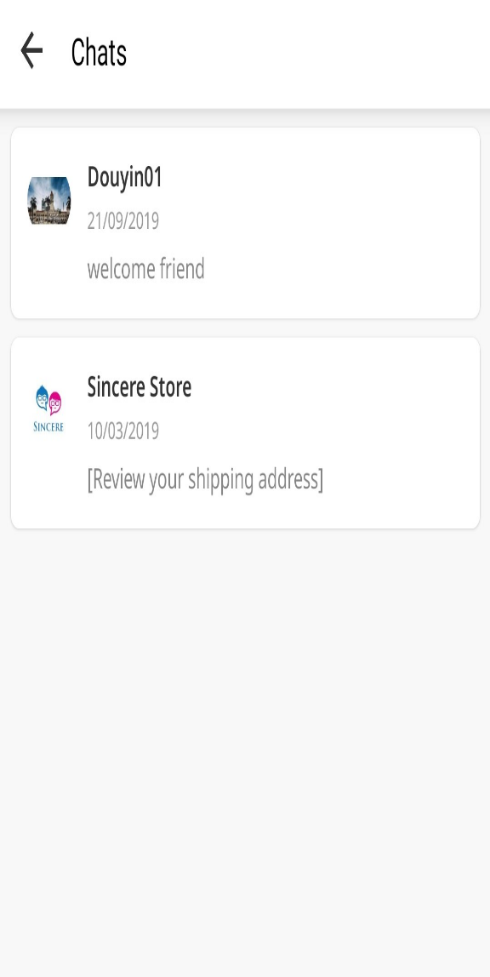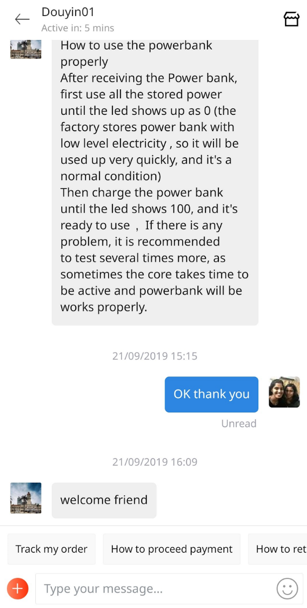

2. There is cashback with lazada e-wallet

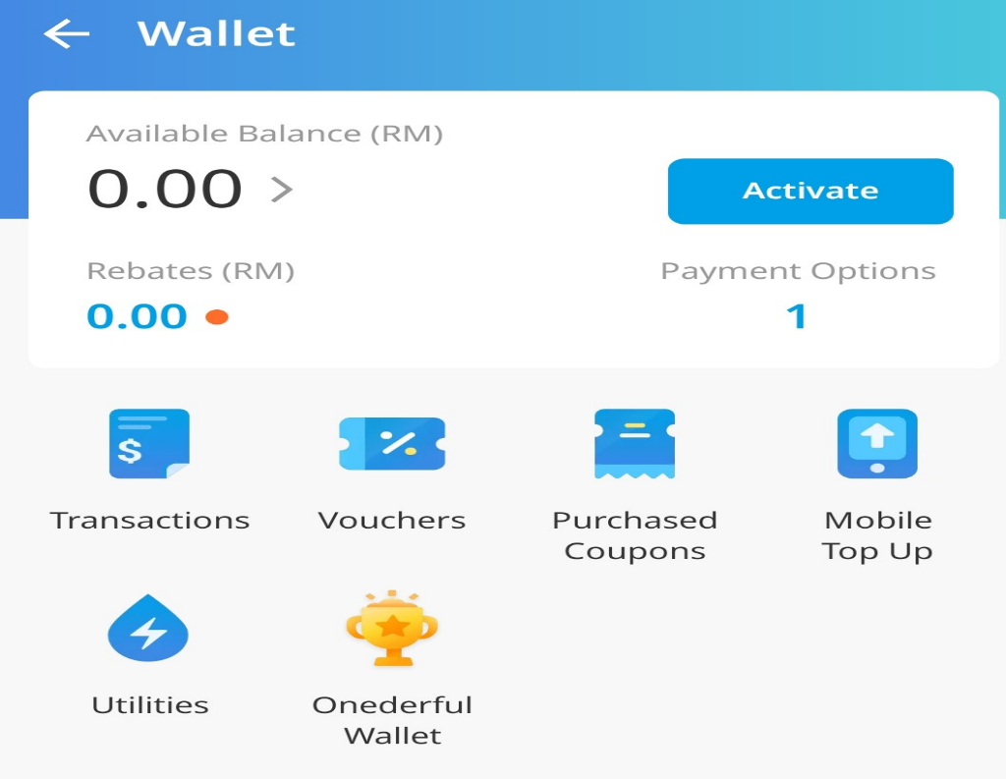

3. We can follow our favorite storE

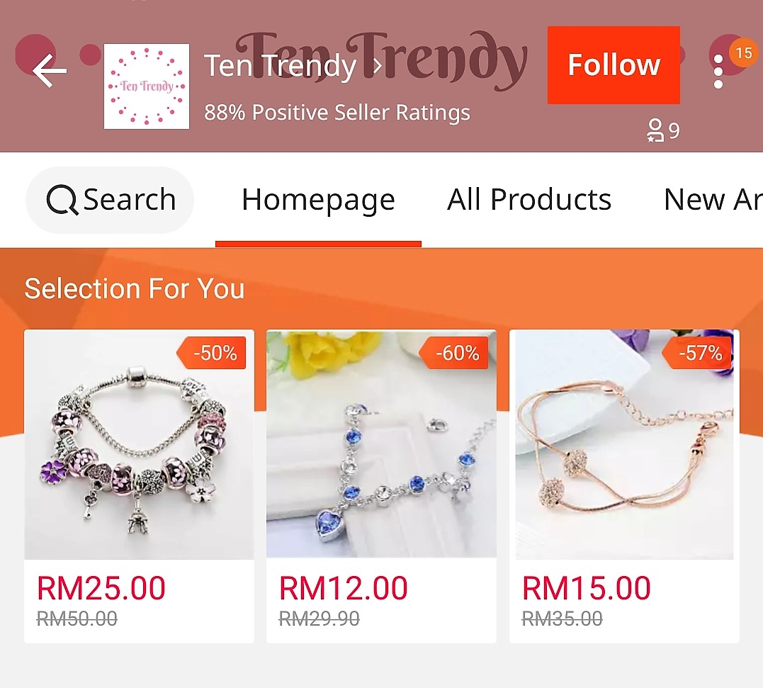

**PROS**

1. Their scale of online presence
2. They have good shipping terms
3. Flexibility of account creation

**CONS**

1.  Lazada is more to customer-focused and not seller-focused

2.  Sellers can't sell their brand outside border

3.  The marketplace fee is high

**Review on Shopee**

Prepared by: HARRI GANESH A/L G CHANDRA BOSE (1191100277)

***SHOPEE***



Founded: Shopee was founded in 2015

Founder: Forrest Xiaodong Li

CEO: Chris Feng

Industry:  E-commerce

Headquarters: 5 Science Park Drive, Shopee Building, Singapore

Key people: 1) Forrest Xiaodong Li

                    2) Chris Feng

**Introduction**

Shopee first launched in Singapore in 2015, and since expanded its reach to Malaysia and other countries as well. Shopee presents an expansive range of products, a social community for exploration, and smooth and satisfactory services. Shopee is one of the most famous by Tech In Asia. Shopee provides products for best prices compared to other online shopping portals.. Shopee is one of the e-commerce platforms for their customers.Shopee has a trust seller and anyone can start selling their product in Shopee.

**Features**

1.List a product for free in less than 30 seconds, anywhere, anytime – simply snap a picture, describe the product and set a price.

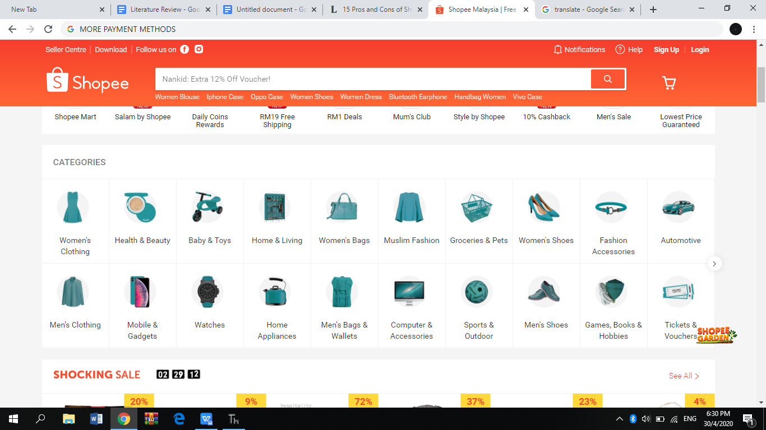

2.Easily figure out which products to restock or offer a discount on.

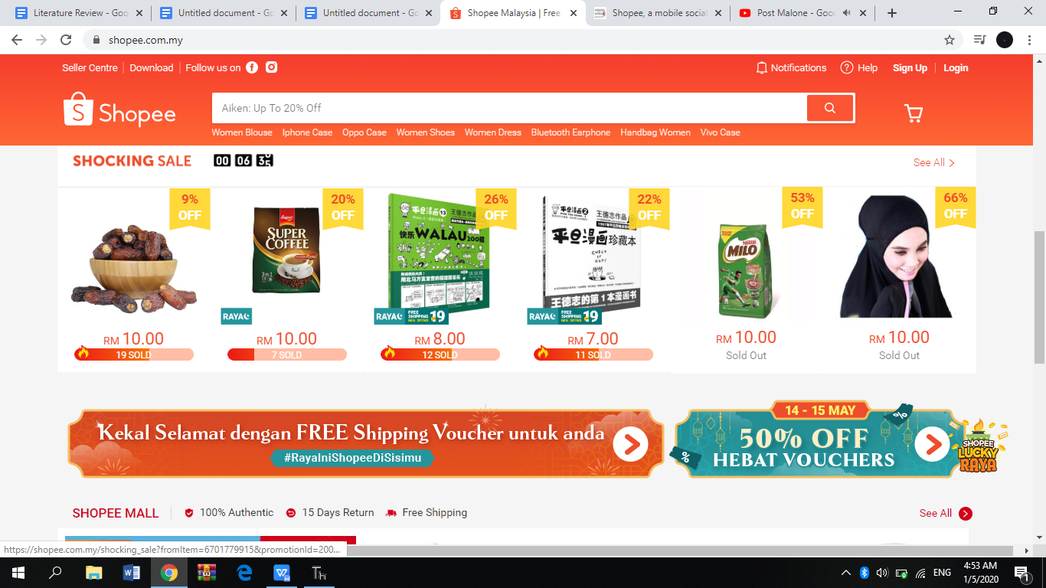

3. 24 hours customer service is provided to the customers

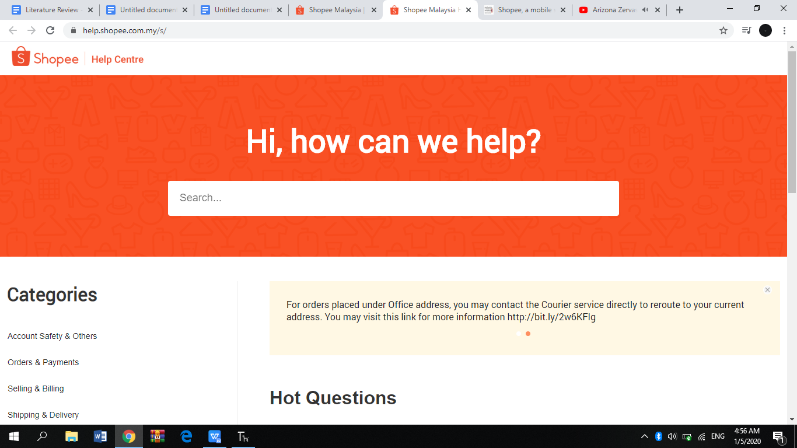

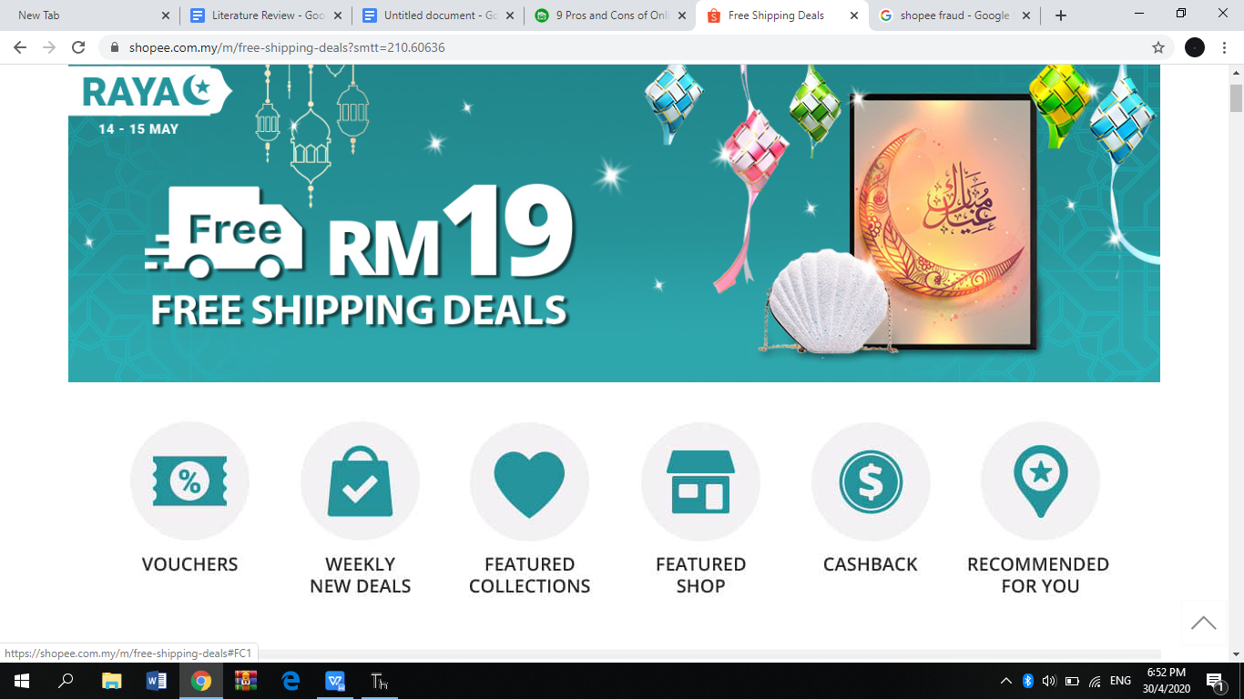

**Pros of SHOPEE**

* Wide variety of products
* Can get detailed information about the product
* Many payments method
* Free shipping across Malaysia

**Cons of SHOPEE**

* Products might fake
* Delays because the products are shipping from overseas .
* Pictures  differ from the actual product

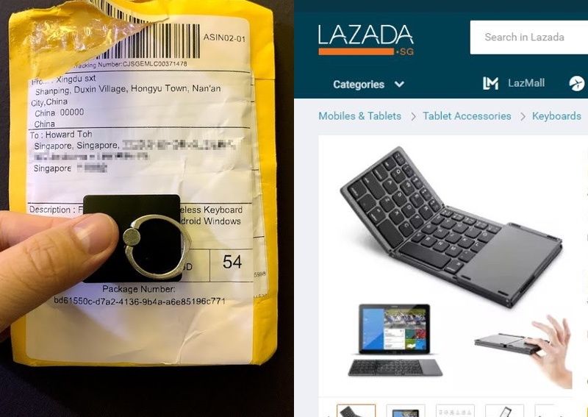

The weakness e commerce like Shopee is with security and cheating internet everywhere, customers are often unwilling for online purchases in using cards for online purchases. Product transferring is an important job.

**Review on Amazon**

Prepared by: Kishen Kumar A/L Sivalingam (1191101423)

***Amazon***

Founded: July 5, 1994; in Bellevue, Washington, United States

Founder: Jeff Bezos

CEO: Jeff Bezos (May 1996–)

Industry:      1) Cloud computing

              2) E-commerce

              3) Artificial Intelligence

              4) Consumer electronics

              5) Digital distribution

              6) Grocery stores

Headquarters: Seattle, Washington, United States

Key people: 1) Jeff Bezos (chairman, president and CEO)

                    2) Werner Vogels (CTO)

**Introduction**

Amazon is an online shopping portal which has been referred to as "one of the most influential economic and cultural forces in the world." It is also known for the world's largest online marketplace, AI assistant provider, and cloud computing platform as measured by revenue and market capitalization. This portal initially started as an online marketplace for books but later expanded to sell electronics, software, video games, apparel, furniture, food, toys, and jewelry. In 2018, a two-day delivery service, Amazon Prime, which has been added to the portal has surpassed 100 million subscribers worldwide. Then, it started to distribute downloads and streaming of video, music, and audiobooks through its Prime Video, Amazon Music, Twitch, and Audible subsidiaries. Amazon portal also contains a publishing arm, Amazon Publishing, a film and television studio, Amazon Studios, and a cloud computing subsidiary, Amazon Web Services. It produces consumer electronics including Kindle e-readers, Fire tablets, Fire TV, and Echo devices.

**Objectives**

-   The purpose of this online portal is to continually raise the bar of the customer experience by using the internet and technology to help consumers find, discover and buy anything, and empower businesses and content creators to maximize their success.

-   Aims to be Earth’s most customer centric site.

 -  Making people believe that empowerment for customers and businesses improves living standards for people up and down the country and drives  economic competitiveness and productivity in a global economy.

 -  Providing everything that customer might need, in order to attract more customers to find products that they need.

**Features**

1) Amazon Day Delivery

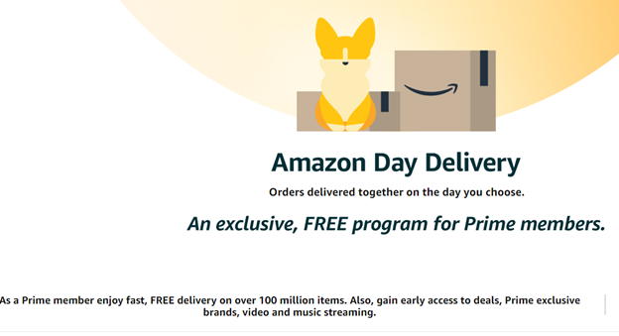

-    Has the ability to buy stuff as soon as we remember that we need it.

-    Let’s imagine what happened when we aren’t at home when the package     was delivered to our home.

 -   As you know that it may cause many problems such as getting soaked by inclement weather or swiped by neighborhood thieves.

-   In order to avoid these problems, this feature lets us pick our delivery day ahead of time.

-  We can do it by just heading to checkout and click "Choose Your Amazon Day" before we place our order.

2)    Amazon Warehouse and Amazon Outlet

                                                                  Image 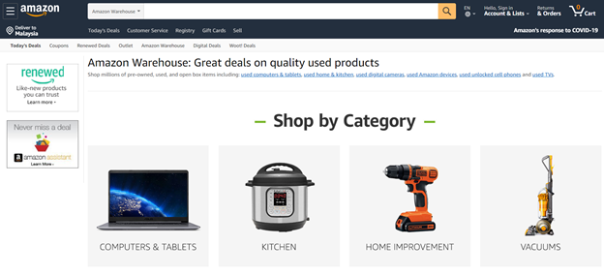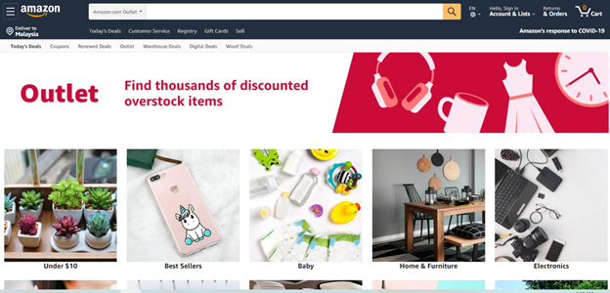

-  Image 1 known as Amazon Warehouse is a particularly useful place to hunt for discounts.

-  Amazon sells these products itself, usually from a stock of refurbished, returned, opened, or cosmetically defective merchandise.

-  The goods may not come with their original warranty, but we'll get Amazon's stellar return policy, along with Prime's two-day shipping.

-  In a similar vein, you can take a look at the lesser-known Amazon Outlet which is the Image 2 for similar clearance items.

3) Amazon Prime

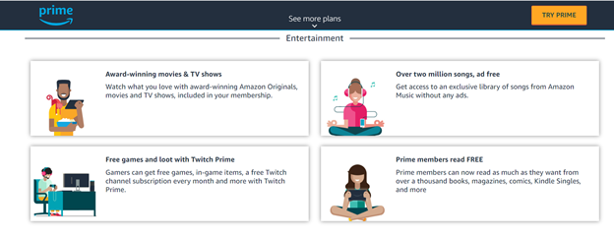

-  Simply link our family members’ accounts to ours in the Amazon Household menu and we're done.

-  Adults in the same home will be able to use two-day shipping and access other Prime benefits such as streaming video, cloud photo storage, and Kindle books on Prime Reading.

-  We can even share purchased books with any of the family members.

-  If we have kids, Amazon Household will let us link them to our account for certain benefits, including streaming video.

-  By this way, It is beneficial to everyone in our house too.

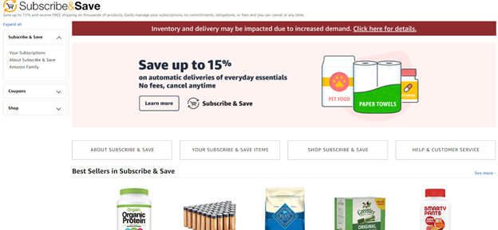4)  Subscribe and Save

-  This is a feature that lets us schedule recurring deliveries of certain essentials at a 5% to 15% discount.

-   The discounts might seem small, but as we subscribe to more items, Amazon boosts our discounts.

-   We'll get an email when a shipment is about to go out, and if we aren't ready for one of the items, we can head straight to the Amazon site and delay the shipment to a later date.

-   If we're ordering something like diapers or baby food, Amazon Family will net us an even bigger discount on subscribed items.

**Pros of Amazon**

-  Amazon allows users to submit reviews to the web page of each product or they can rate the product on a rating scale from one to five stars.

-  Customers may comment or vote on the reviews, indicating whether they found a review helpful to them. If a review is given enough "helpful" hits, it appears on the front page of the product. From this, we knew that this site uses helpful reviews to develop itself.

-  Content search makes it to attract a lot of customers and gain a lot of profit. For an example, "Search Inside the Book" is a feature which allows customers to search for keywords in the full text of many books in the catalog.

-  Third-party sellers who sell products to Amazon helps Amazon to gain revenues.

-  Discounts, sales and offers are great ways of converting visitors to potential buying customers. Daily deals and discounts will engage more customers in the product category. This also opens the possibility of appearing on Amazon under the category of hot deals categories, which will generate maximum traffic.

**Cons of Amazon**

-   For buyers, there is a high risk of getting fungible items because we always will get the stock from the nearest seller that has an inventory store from our home even though we ordered from a different seller.

-  The site is not free even though we sell the products through the site. Even though the initial setup costs are cheap and the rates are better than what we negotiate, however, as the contract progresses, we might have to spend well.

-  We may lose marketing opportunities because Amazon does not let sellers know buyer’s email addresses so that deprives us of opportunities to promote our brand, up-sell and cross-sell products, launch new products, and more through email campaigns.

**Review on Zalora**

Prepared by: Nurul Syaqeera Binti Ismail (1191101189)

Founded: Early 2012 by *Rocket Internet*

Headquarters: Singapore

Managing Director:  Magnus Grimeland, Chris Feng, Steven Kim, Luca Barberis, Tito Costa, Michele Ferrario, Tan Wee

Product Manager : Ahmad Sarjono

Mission : Provide customers a dynamic, ever-evolving and passionate business environment.



I am convinced that most people recognize Zalora, Asia’s leading online fashion destination. It is the largest and fastest growing fashion focused e-commerce site across Southeast Asia. Zalora are present in Singapore, Indonesia, Malaysia & Brunei, the Philippines, Hong Kong and Taiwan.

Effectively, Zalora was written in JavaScript programming language. Other than that, Google BigQuery helps Zalora decide whether its websites or apps introduce goods to consumers. Consumers can choose from a variety of choices especially across men’s and women’s fashion apparel, shoes, accessories, and beauty categories online since Zalora offers an extensive collection of over 500 top international and local brands and designers. Not only that, eversince the covid-19 pandemic, they took a step forward to sell essential things like, household materials, foods, health products, electronics and much more.

**Features**

* Countless promotions and deals customers can grab - this will attract more attention, not to mention during celebration day.

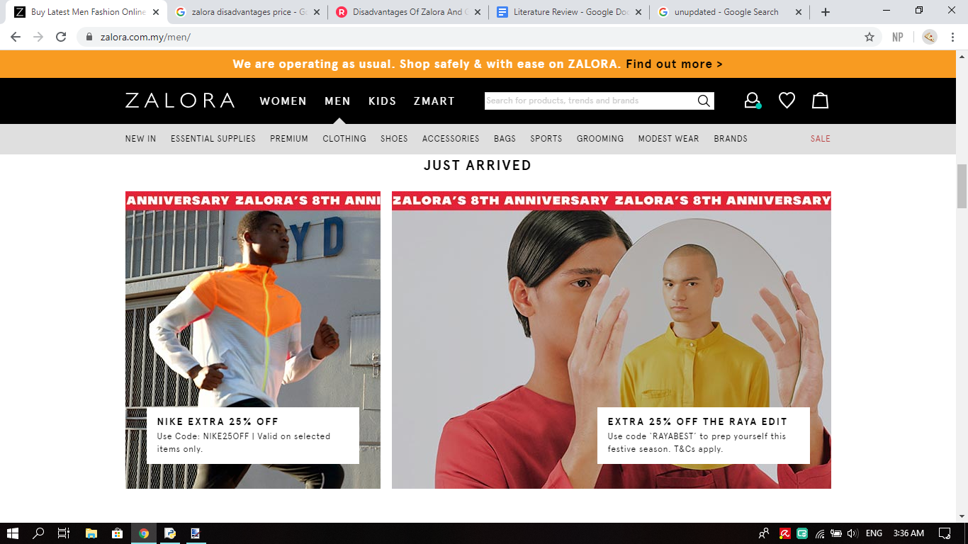

* Trustworthy website - After every purchasement, the customer service team will inform buyers the current status of their order. Each order requires an online tracking number through which buyers can follow their orders till delivery. Statiscally, it is said that an average of 16 million visits a week.

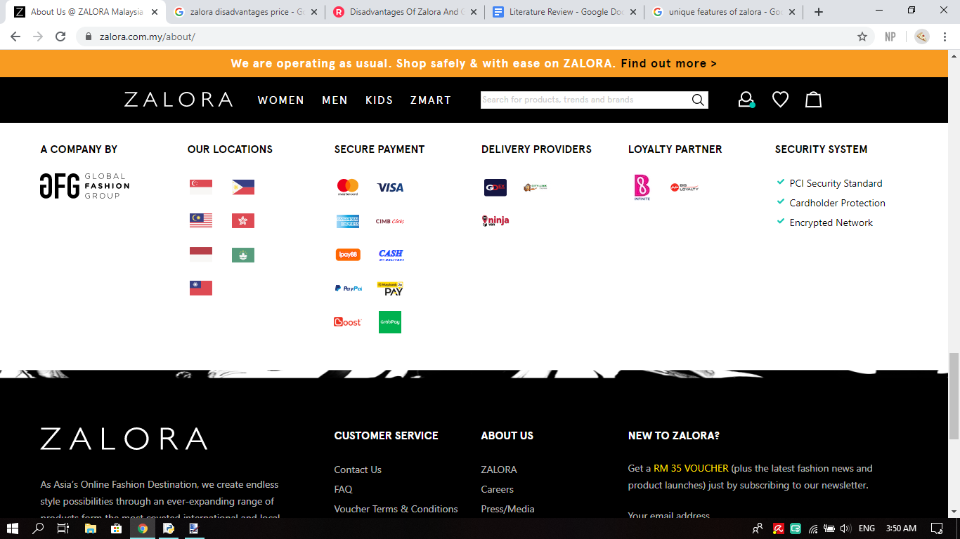

Like any other things, of course this application have their own strengths and that is :

* Support from other countries
* Easy navigation and intuitive operation
* Variety payment method including cash on delivery
* Free returns policy within thirty-days of receipt
* Free delivery for every purchase above RM99

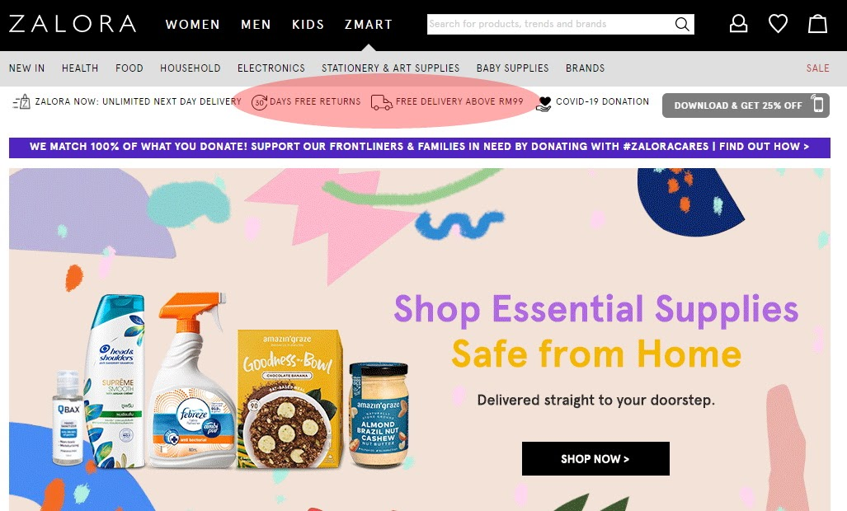

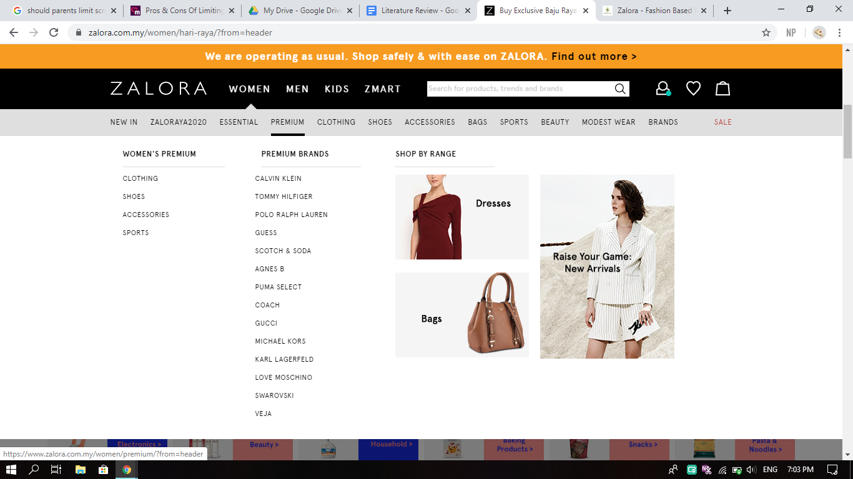

Image above is one of the categories of products that are offered.

Meanwhile their weaknesses are:

* Did not provide enough picture of the product
* Some product may be over priced
* Unprofessional customer service - outdated chatting room causing late replies or not reply at all.
* Faulty errors - As an illustration, someone wanted to buy a limited edition bottle, in black but it is out-of-stock. So, he bought another colour, blue which stated “Only 1 item left”. After purchasement, he received a phone call and an email claiming that the product is already out-of-stock.

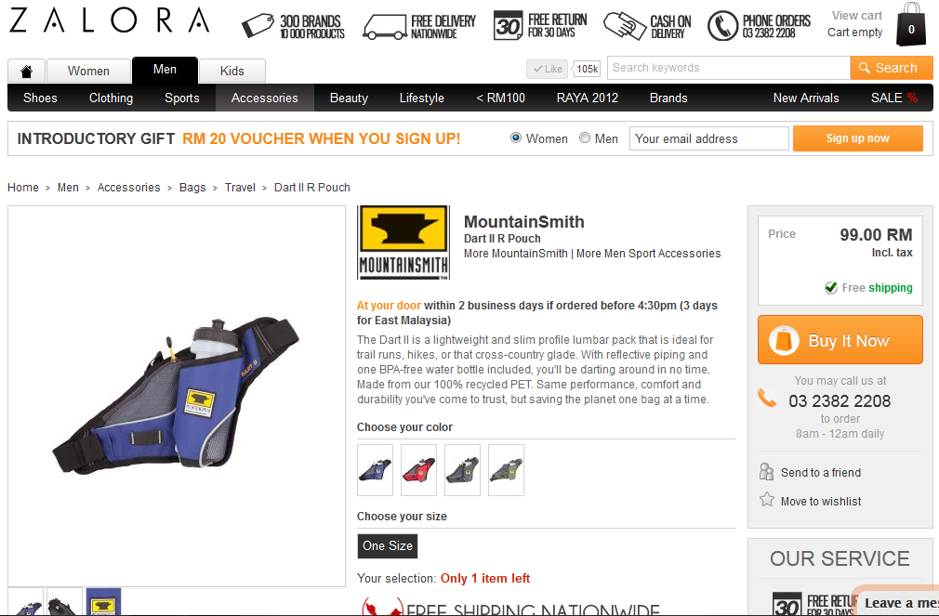

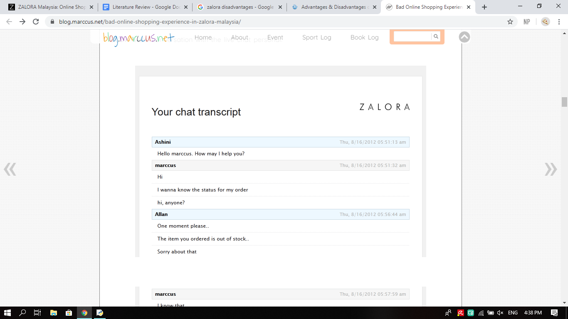

**PROPOSED SOLUTION**

* 1. **Online shopping saves time**. Customers do not have to stand in queues in cash counters to pay for the products that have been purchased by them. The customers can also look for the products that are required by them by entering the key words or using search engines.
  2. **Online shopping is convenient**. Customers can purchase items from the comfort of their own homes or work place. It is also easy to cancel the transactions so they do not need to waste their energy.
  3. **More variety and the choices** online are amazing and can find almost any brand or item you're looking for.
  4. **No pressure in online shopping.** Generally, in physical stores, the sales representatives try to influence the buyers to buy the product. There can be some kind of pressure, whereas the customers are not pressurized in any way in online stores.
  5. **Price comparisons are also available online**. It display the whole range of products offered by them to attract customers with different tastes and needs. This enables the buyers to choose from a variety of models after comparing the finish, features and price of the products on display.

**FLOWCHART FOR DATASTORING**

Prepared by: Sharveena Padmaraj (1191101614)

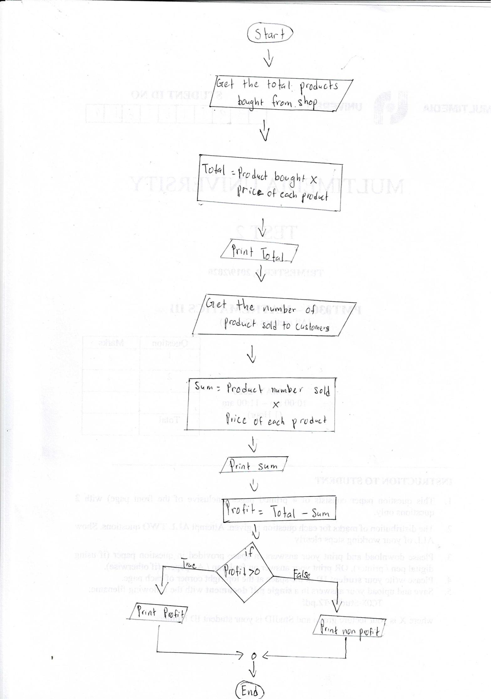

**FLOWCHART FOR PAYMENT SERVICES**

Prepared by: Kishen Kumar A/L Sivalingam (1191101423)

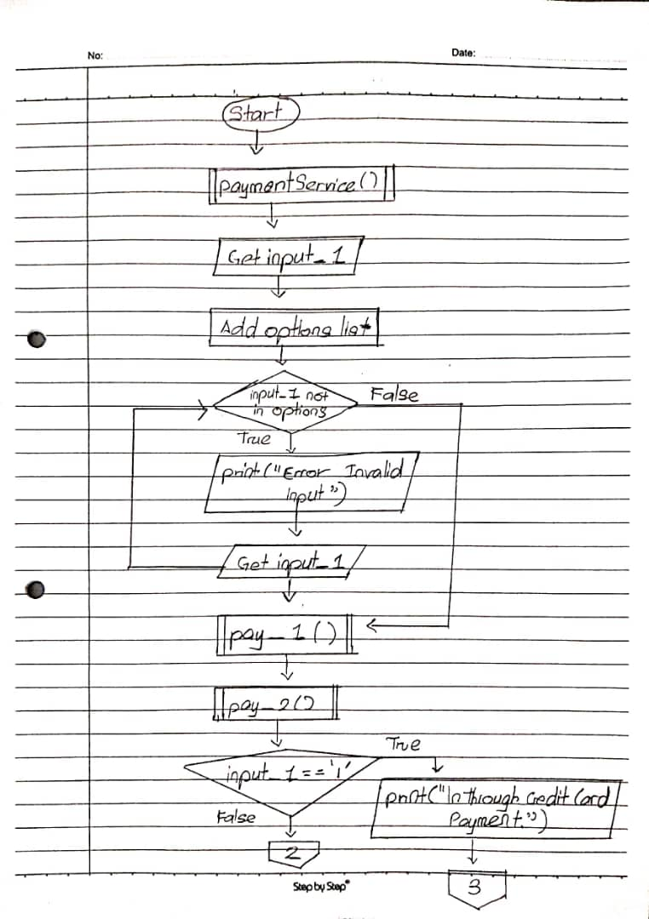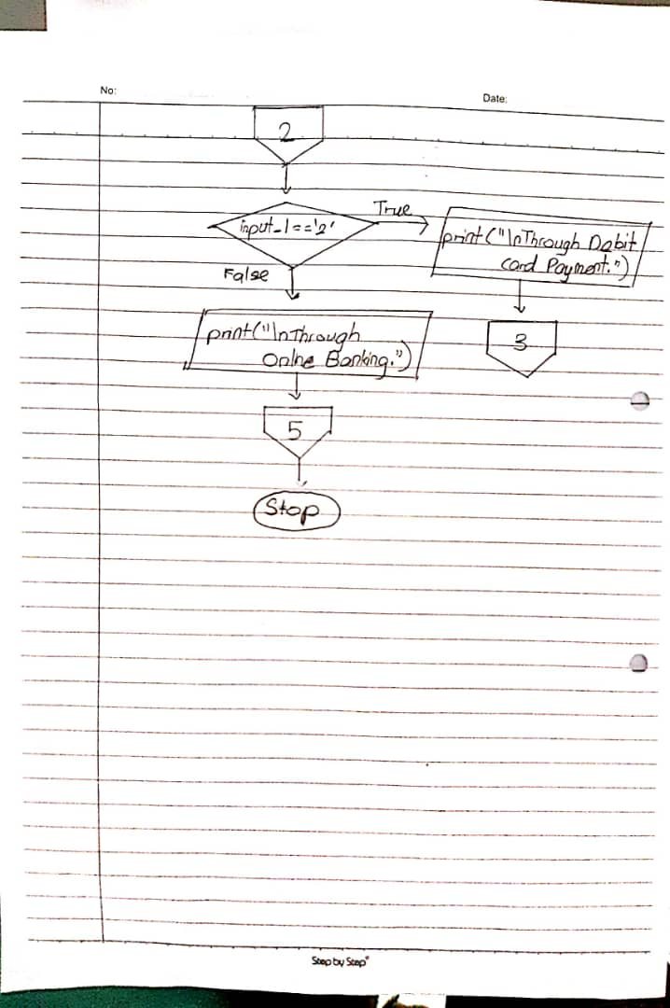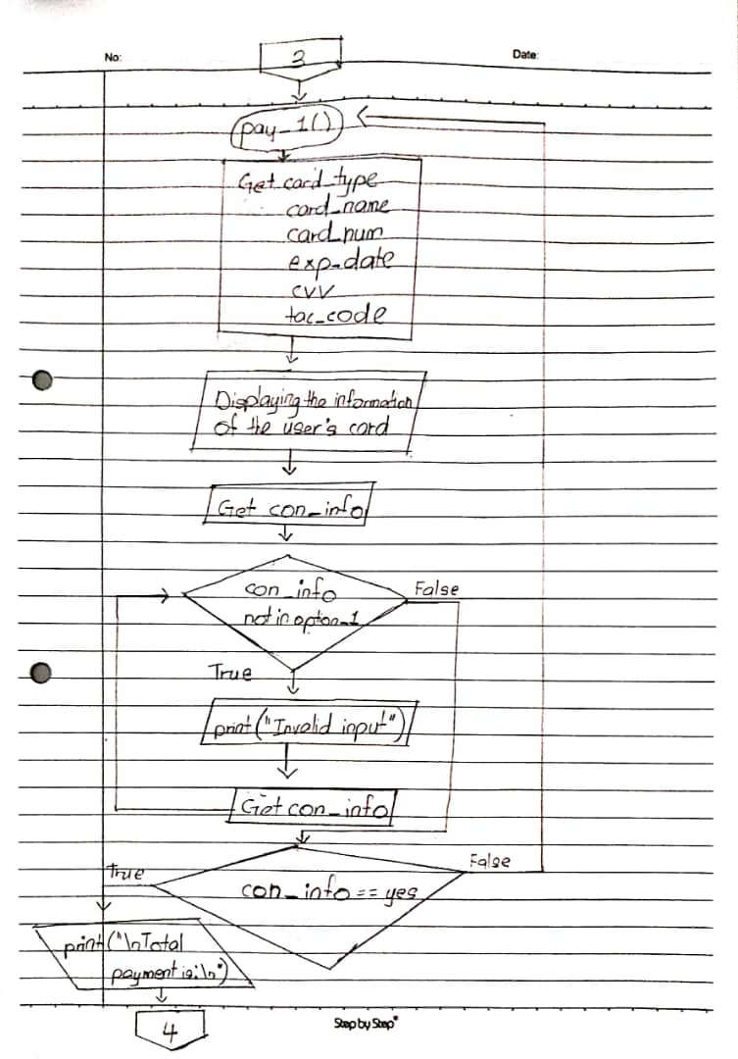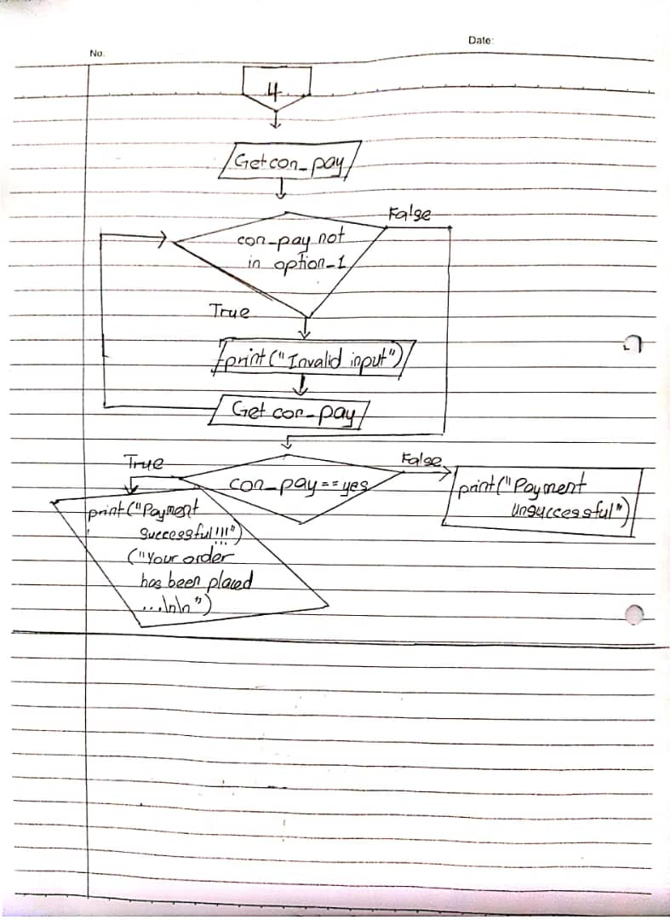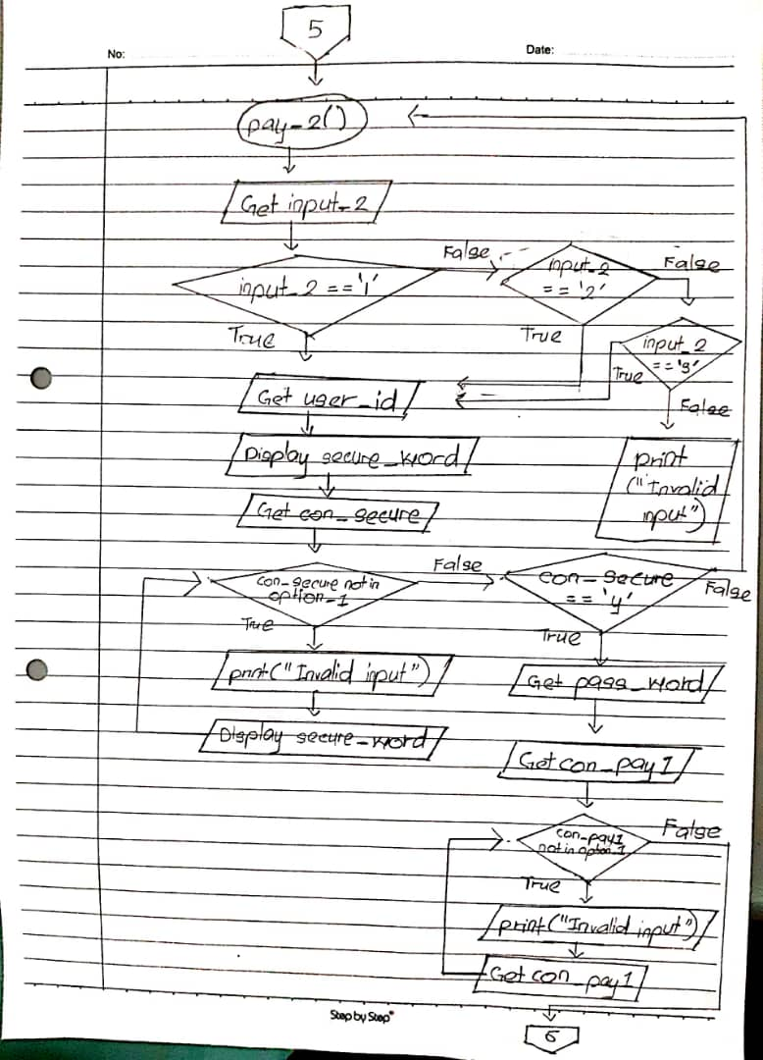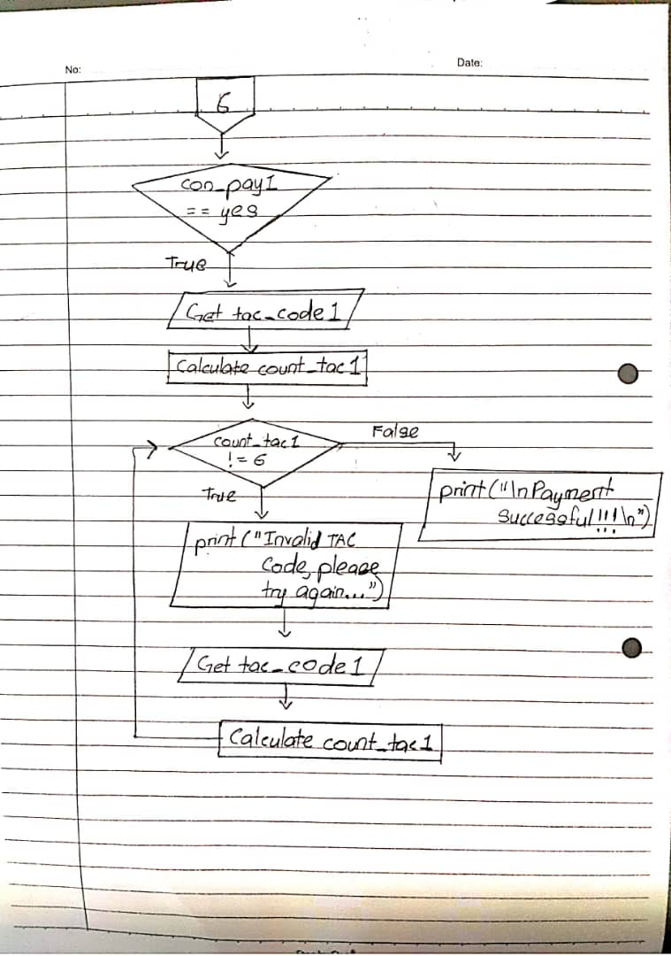

**FLOWCHART FOR SHOPPING CART**

Prepared by: Nurul Syaqeera Binti Ismail (1191101189)

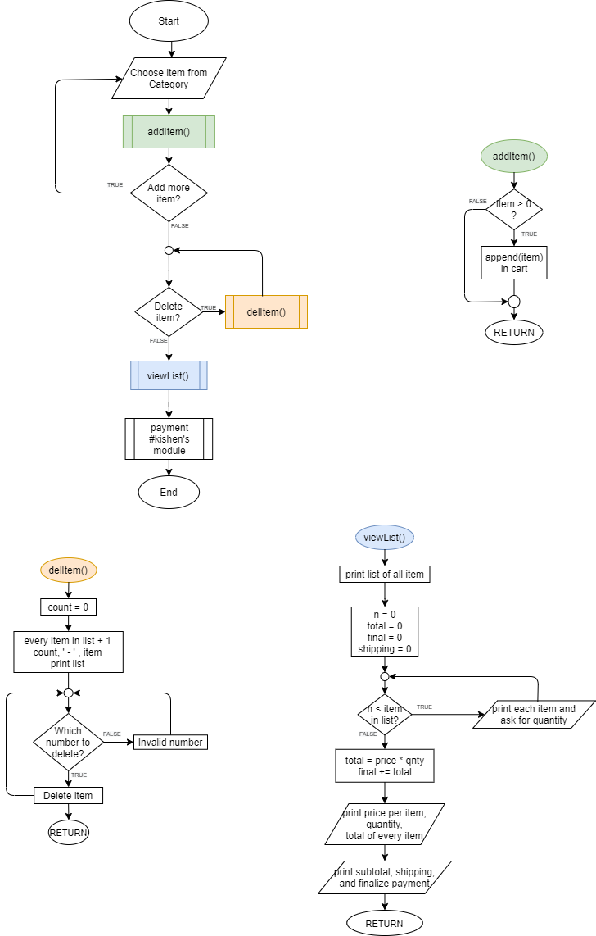

**FLOWCHART FOR CUSTOMER SERVICES**

Prepared by: HARRI GANESH A/L G CHANDRA BOSE (1191100277)

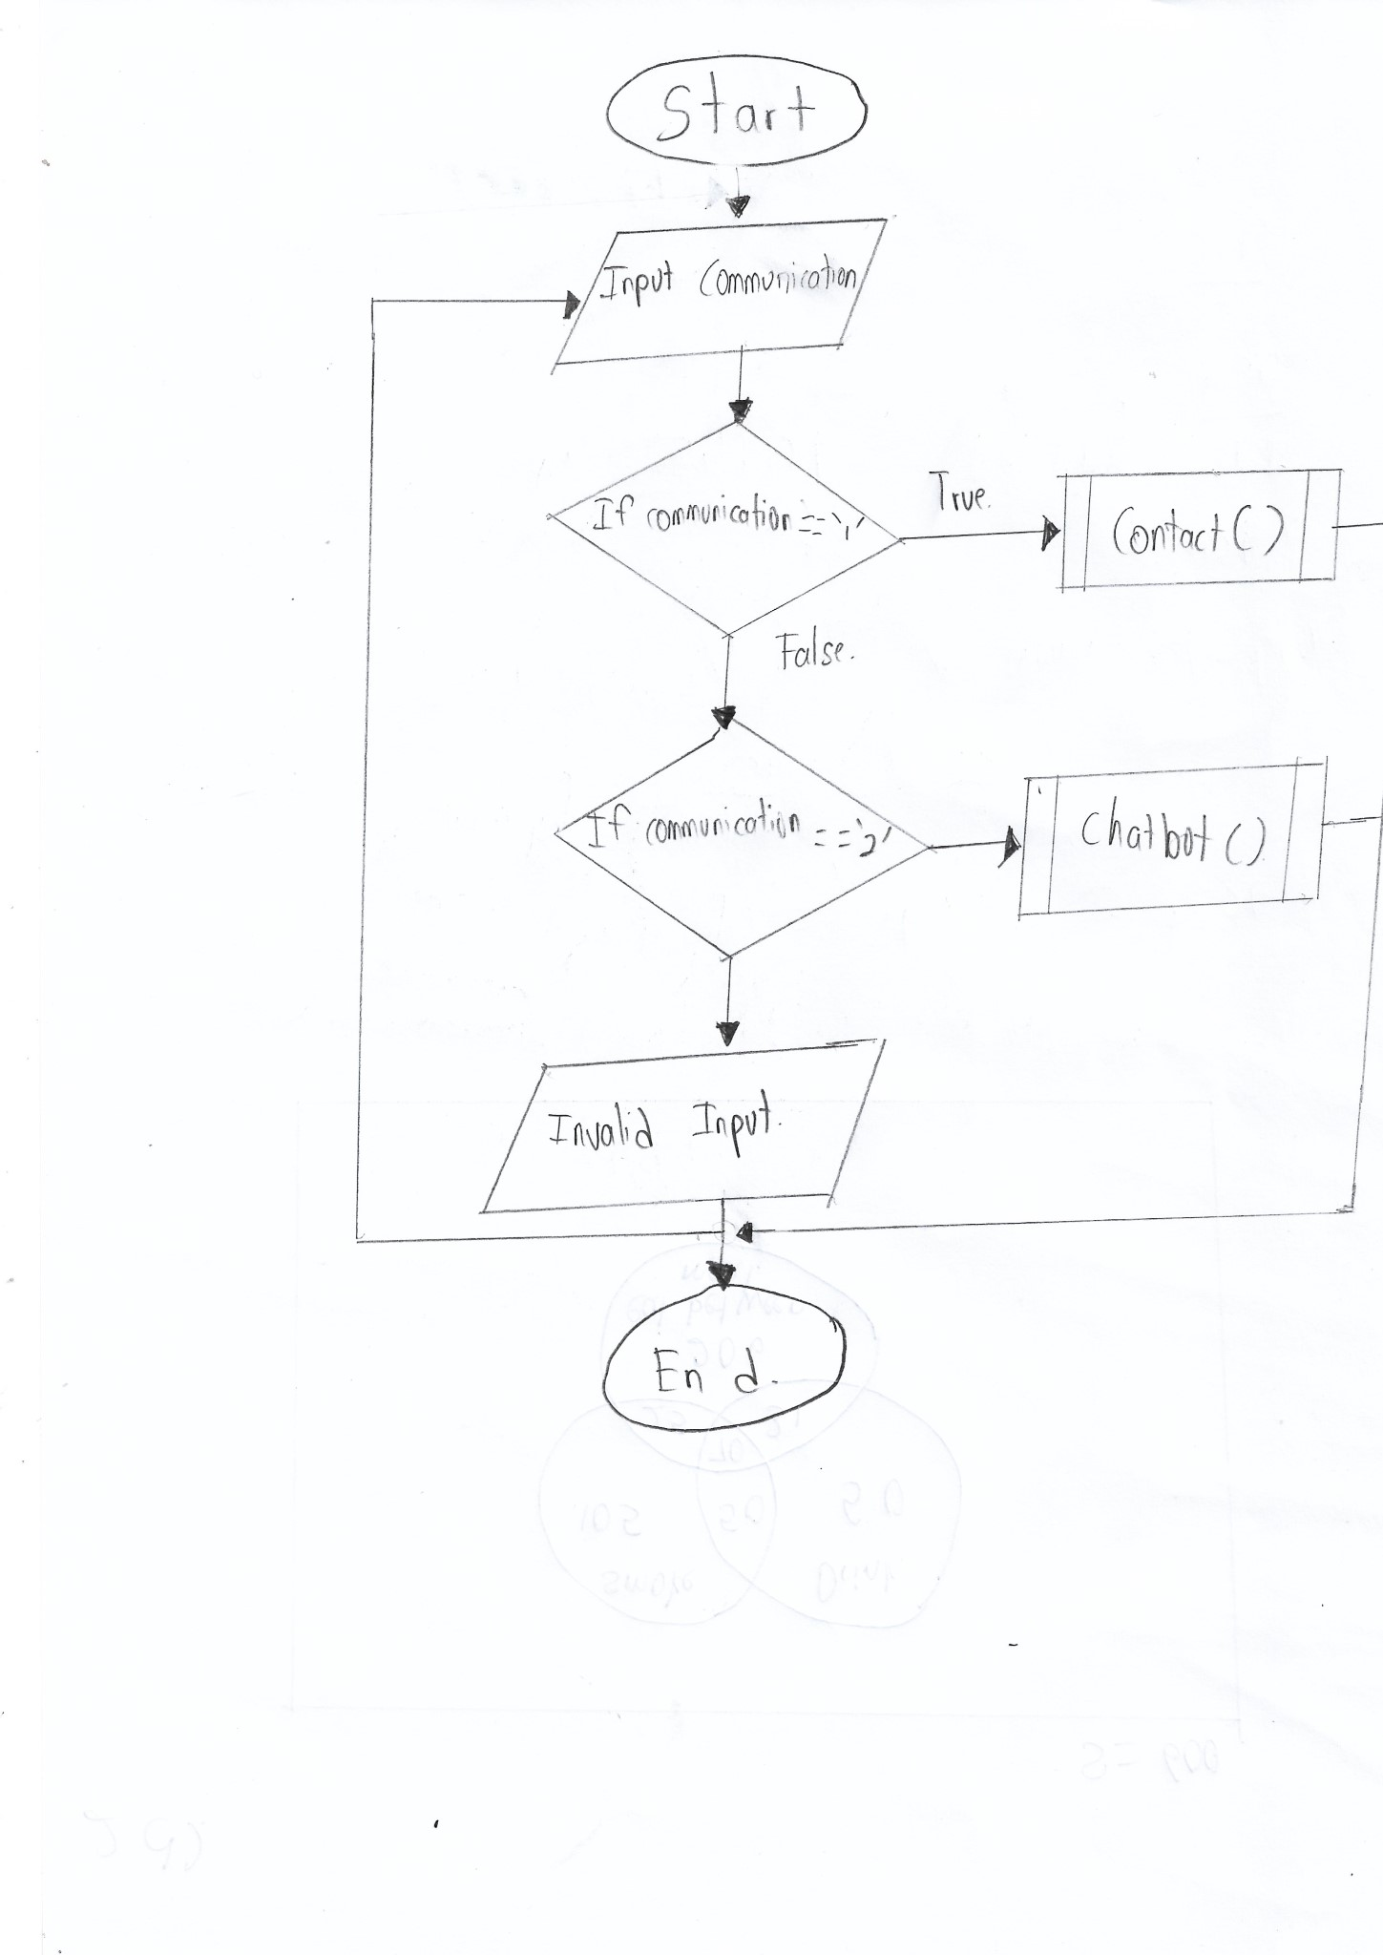

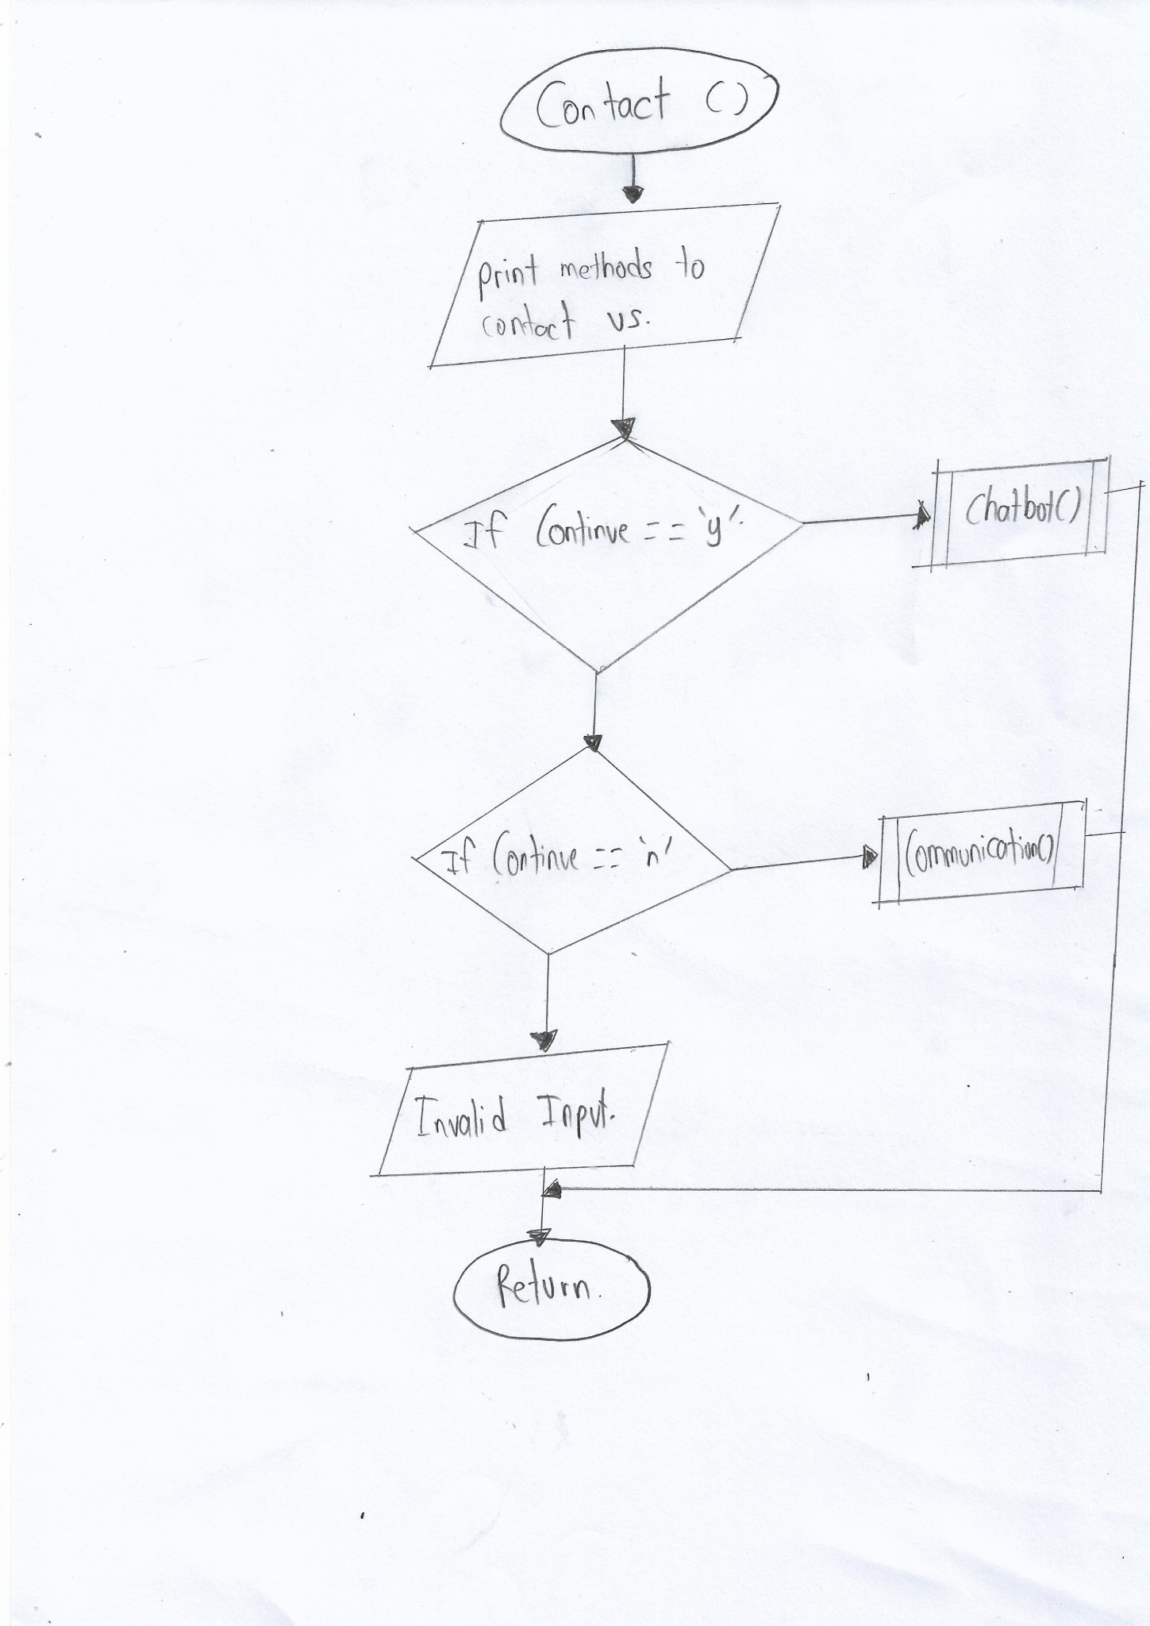

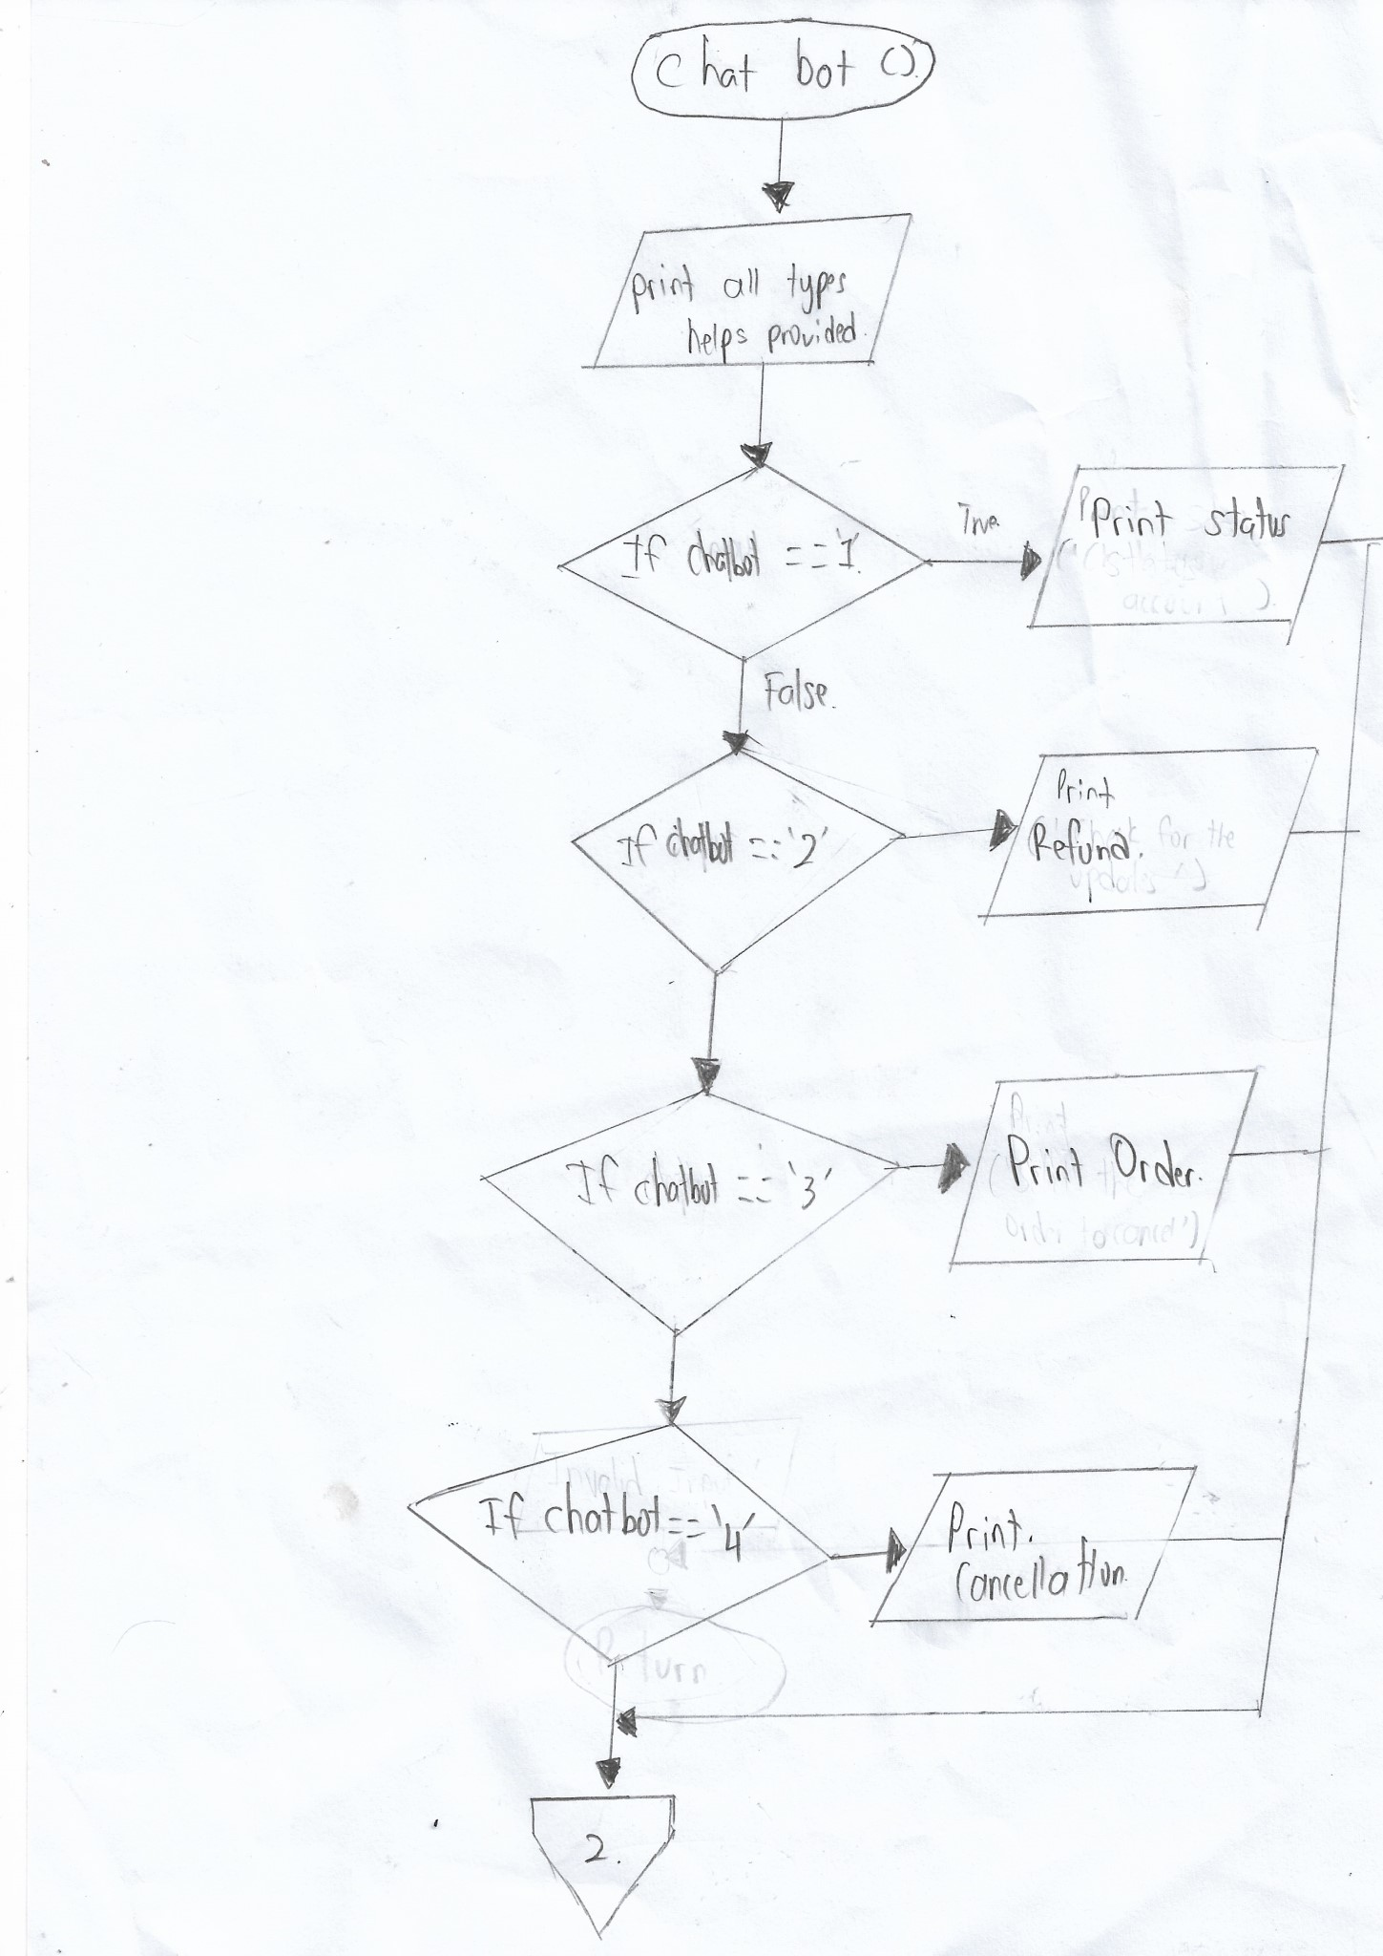

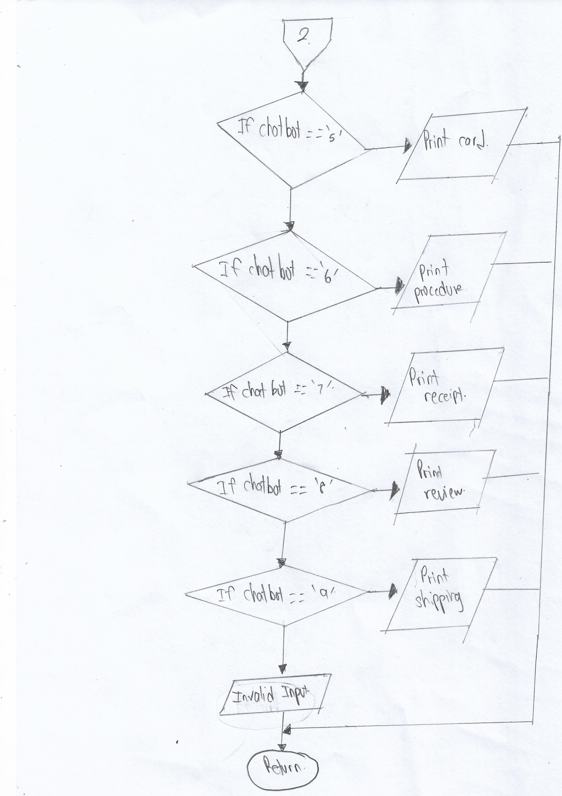

**CONCLUSION**

In conclusion, online shopping websites are becoming more popular and powerful. Although online shopping has brought plenty of benefits to society, there are some negative concerns of online shopping too. To avoid cybercrimes, consumers must take care while using a MasterCard via online shopping website. Additionally, web programmers have upgraded and enhanced the safety level of the web site to avoid those crimes.in addition, customers do not need to stand in queues in cash counters to buy the products that are purchased by them. They will shop from their home or work place and don't have to spend time travelling. The customers also can search for the products that are required by them by entering the keywords. This saves time for the customer. Online places provide shoppers with more varieties. In shopping portals customers can find many of the brands and items that you are looking for online. Most importantly, online shopping is not geographically limited, and customers can visit international stores as well and buy products they have always had eyes on and get it shipped to their place. Eventually, all consumers will adapt to the web shopping technology and are ready to enjoy the convenient, innovative way of shopping. Most of the requirements have been fulfilled. This project made here is just to ensure that this project could be valid in today's real challenging world. The project was made and tested. Currently the system works to sell products in e-commerce or online shopping portals.